# CHAPTER-1 INTRODUCTION

## 1.1 Project Overview

Big Data is distinguished from other data by its volume, velocity, complexity, and value [1]. There is an extraordinary quantity of data and a rapid rate at which something is just being generated, which again is called volume and velocity. Flexibility and heterogeneity are inherent in Big Data (variety). To get the most out of the data, you'll need specialised tools and procedures. Big data exploration has been aided by the development of new algorithms, scalable and high-performance processing infrastructure, and analytics tools. Convolutional neural networks, for example, have been frequently used in the analysis of large amounts of data [2]. NoSQL databases are used to store and retrieve massive data, while Hadoop offers a scalable and high-performance architecture [3].

Big data applications and infrastructure must always be tested and validated in order to assure resilience and high availability. Validation and verification jobs are made more difficult by the four qualities of big data. There is a huge issue in selecting and validating data for big data analysis because of the sheer variety and number of big data, which is crucial to the efficacy and performance of big data analysis. Previously conducted studies have demonstrated that datasets with aberrant data have a significant impact on the accuracy of research methodology [5]. Due to the lack of test oracles, many data analytics solutions are difficult to test.

It is impossible to use other methods to validate sophisticated software systems. It's also challenging to evaluate the machine techniques and algorithms used to analyse big data because of the amount of data and the uncertain intended outcomes. Big data quality assurance, machine learning algorithm verification and validation, and "non-testable" scientific software verification and validation are all important, and very little work has been done on the systematic validation and verification of a big data system.

Researchers in this publication are concerned in the confirmation and automated identification using huge data, and in verifying and validating analytical software and algorithms. Machine learning characteristics such as features extraction, extraction, and selection are often discussed in this article.

# CHAPTER-2 LITERATURE SURVEY

**2.1 Survey papers**

Renaissance in database management: Navigating the landscape of candidate systems

New data management models, designed to sustain billions billion data operations per second, are being driven by the demands of big data, while old relational models are evolving to keep up. As that the product environment changes, the authors present practical techniques to help data managers select candidate solutions and ways match their acceptance criteria.

Analysis of cellular objects through diffraction images acquired by flow cytometry

There are both global and local patterning changes detected in the diffraction pictures taken from a cell sample using the side scattering directions. Worldwide pattern diversity is linked to item identification and morphology variety, as shown in this study. These photos may now be separated into three global patterns using an autonomous computer vision approach. Automated 3D cell categorization is now possible using a previously discovered approach for assessing local texture pattern differences in dispersion pictures combined with increased method.

Models of object recognition

Computational neuroscience's overall purpose is to figure out how biological representations identify things by their features. Categorization and identification are comparable from a computational learning perspective, but they reflect distinct trade-offs between sensitivity as well as invariance. To accomplish an assigned assignment, the same class of models may be used for all of them. We begin with a quick survey of some recent developments in computational vision before turning our attention to feed-forward, view-based models that have been backed by psychophysical and pharmacological data.

Development of a diffraction imaging flow cytometer

Angle-resolved distribution of reflected photons from a particle generated by focused beam is recorded in diffraction pictures, which is significantly correlated with a particle's 3D shape. Clear diffraction pictures may be obtained in a laminar flow using a flow chambers with an aeroplane configuration that we demonstrate. According to Mie theory, pictures of styrene balls of varied diameters were taken and discovered to be quite similar. Measured pictures may be utilised to obtain sphere dimension values using the Fast Fourier transform (FFT). The above results demonstrate the tremendous potential of increased diffraction imaging confocal microscopy for the extraction of three dimensional morphological characteristics of cells. These results.

2.2 **Technology Survey**

**Why Machine leaning [ML]?**

“As a subset of artificial intelligence, machine learning (ML) concentrates on understanding and take judgments without the need for human intervention by assessing and interpreting data patterns, structures, and developments”. "AI" stands for intelligent machines. To put it more simply, machine learning involves users to feed massive volumes of data into an algorithm running on a computer. The algorithm then does an analysis on the data and offers data-driven conclusions and recommendations based only on the data that would have been fed into it. In the event that any modifications are discovered, the algorithm should be able to utilize this knowledge for the future to improve its decision-making.

**How does machine learning work?**

The following are the three components that make up machine learning:

1. The methodology to arriving at decisions that is implemented all throughout process of computing

2. the myriad of circumstances and considerations that should be properly considered before choosing a path of action.

3. The choice is determined by the foundational understanding, which educates the created system how to recognise the characteristics.

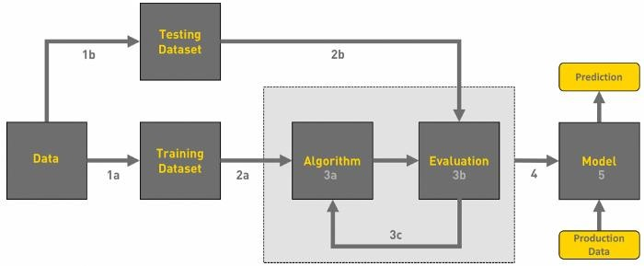

Fig 2**.1.1.1: Machine Learning Workflow**

"Machine learning has applications in numerous sorts of businesses, include manufacture, retail, healthcare and life sciences, travel and hospitality, banking sectors, and energy, feedstock, and utility companies," according to one source.

**The following are some examples of applications**:

1) Manufacturing: The process of monitoring the current condition and doing maintenance in order to predict potential issues

2) Retail: By making the customer's shopping experience more enjoyable overall.

3) The objective of healthcare is to evaluate a condition and estimate the potential danger it poses or the amount of harm it will produce.

4) In the hotel and travel industry, setting the maximum possible pricing in relation to the shifting landscape of the market competition.

5. Analysis of the legislation and estimation of the probable dangers associated in the company when it comes to financial services.

6) Energy: In order to fine-tune production, it is important to have a thorough understanding of both the demand and indeed the market.

**The following are some of the most widely used ML algorithms**:

➢ Linear regression

➢ Logistic regression

➢ Decision tree

➢ SVM algorithm

➢ Naive Bayes algorithm

➢ KNN algorithm

➢ K-means

➢ Random forest algorithm

➢ Dimensionality reduction algorithms

**2.2.2 Types in ML**

There are three distinct categories that have been established.

1) Supervised learning

2) Unsupervised learning and

3) Reinforcement learning.

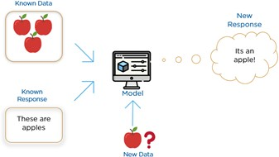**Fig 2.2.2.1: Types of Machine Learning**

**2.2.3 Supervised learning [SL]**

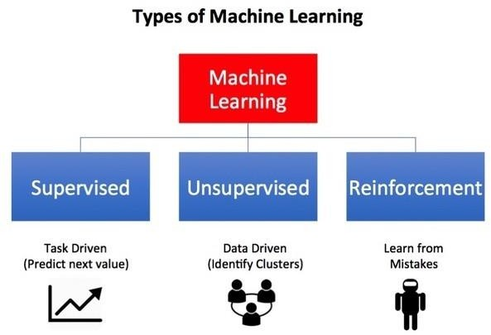 Reinforcement learning is the most commonly used machine learning paradigm. It is the easiest to understand and implement. As a result, supervised learning is usually referred to as task-oriented learning. It is laser-focused on a particular task, supplying the algorithm with increasing numbers of samples until it can consistently do it.

**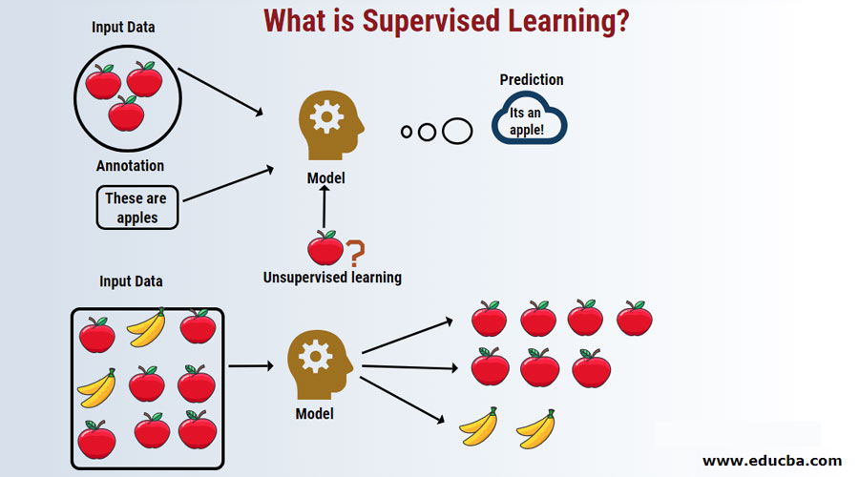**

**Fig2.2.3.1: Supervised learning**

In the previous illustration, the proposed system is attempting to identify whether the fruit in conundrum is an apple or another category of fruit. If the proposed training has been completed effectively and is able to correctly identify the target object, then it is prepared to provide an output for all of the personal information that is associated for maybe an arbitrary number of cycles.

### 2.2.4 Unsupervised Learning[UL]

Learning in an unsupervised situation is the exact opposite of learning in a sterile situation. It does not have any labels of any kind. Instead, we will feed our computer a vast amount of data and provide these with the materials it requires in order to comprehend the characteristics of the data. After that, it is able to learn how to organize, arrange, and cluster information data in such a manner that it can be comprehended by a human.

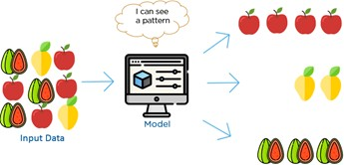

**Fig2.2.4.1: Unsupervised learning**

In the preceding illustration, we could see that the group contains not just apples but also a diversity of these other fruits. The learning model, which has previously been trained and is capable of detecting things, will place items that already have similar characteristics together and correctly estimate the result of the situation.

### Reinforcement Learning[RL]

This data learning method is entirely based on trial and error, and while we will get an accurate result, we can decide what we can do or what action can be taken for what type of data and how we will get the result. .There are a few mechanisms in ML for reinforcement learning, which are environment that the agent uses to interact, and the other thing is agent and action. Here the action is what the agent does .

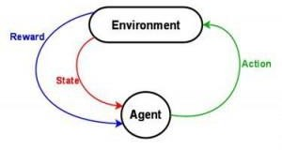

Fig 2.2.5.1: Reinforcement Learning

Learning algorithm stands out as a distinct kind of teaching when compared with supervised and unsupervised. While it is easy to tell the difference between supervised and unsupervised learning (when it comes and whether or not there are labels involved), it is not as simple to distinguish between reinforcement and ou pas learning.

## 2.3Existing and Proposed System

**EXITING SYSTEM:**

Analysis of big data relies greatly on the performance of data extraction and validation, but the amount and variety of big data presents a formidable obstacle.

The accuracy of data analysis might be injuries sustained by the occurrence of aberrant data in datasets, so according previous research. Current tests or the expansion of existing ones may not fully fulfil the stated programme network parameters, thus new Obtained respectively must be established and existing MRs improved.

It is possible to create superior test oracles by examining the current software engineering data, such as test results, using cutting-edge methods like machine learning. Oracles that can authenticate the results of formative assessments are the ultimate objective of MR development.

**Disadvantage:**

The stratified N-fold 10-fold cross - validation and confusion matrix are used to assess the machine learning algorithms' performance. CMA is used as a case study to demonstrate the creation of the conceptual methodology. Verification and validation of the data, software systems, and techniques in CMA show how successful the framework is.

It is really challenging to evaluate the machine techniques and algorithms used to analyse big data because of the amount of data and the uncertain intended outcomes. Big data quality assurance, machine learning algorithm quality assurance, and "non-testable" scientific software verification and validation are all significant, but little research has been reported on the comprehensive validation and verification of a big data system.

Regular software evaluation and verification approaches may be used to verify and validate a large amounts of data system at the system level. When it comes to verifying and validating the performance of big data systems, basic system evaluation and validation techniques are not appropriate.

**PROPOSED SYSTEM:**

We've also built a framework for rigorously validating large-scale picture collections and for verifying software applications and machine learning algorithms alike.. Automating the selection and confirmation of huge scale picture data in CMA was accomplished using a variety of machine learning methods along with image processing techniques.

Special instruments are needed to remove value from the data. There have been advances in algorithms, direct maintenance, and analytics tools to aid in the study of large amounts of data. For example, deep learning algorithms have already been extensively used for the analysis of large datasets, such as social media data.

Large data sets and a lack of understanding about just the desired results make assessing the machine learning algorithms used to analyse large amounts of data problematic. No systematic validation and verification has been done for big data systems as a whole despite the fact there has been substantial work on quality assurance of big data, the verification and validation of machine learning algorithms, and "non-testable" research software.

**Advantage:**

The architecture provided in this study covers the core verification and validation activities required for each big data application but may be simply expanded to verify and validate additional big data systems.

We show how our technique may be used to the identification of diffraction pictures of biological cells. An reliable classification of cell kinds is possible using the 3D morphological features of a cell obtained in a diffraction picture. We are all made up of cells.

These microorganisms have a wide range of 3D shapes of internal organelles to support their phenotypic and functional diversity. Many disciplines of biology and life science investigation depend heavily on cell assays and classifications..

This technology is used to model and evaluate 3D cell morphology and to recognise and extract morphogenesis patterns from diffraction pictures of living organisms. Morphology fingerprints may be used to describe these patterns, which are derived from correlations among diffraction patterns of light dispersed by cells with differing phenotypes and three dimensional.

**2.4 Feasibility System**

Feasibility study is used to disclose the features of system and designing analysis . the aim of the feasibility study to decide how to decode the issue . It is managed when the obstacles are correctly recognized

The feasibility study for the system has the four types :

* Technical Feasibility
* Economic Feasibility
* Operational Feasibility
* Behaviour Feasibility

**Technical feasibility**

Spyder very neatly coordinates between design and coding part. While the actual development is finished in Python, it provides a user interface for developing an app. At the same time, it provides reliability, availability and compatibility.

**Economic feasibility**

In economic feasibility the main view is analysis of cost . This project entitled “Object detection” is feasible because it does not exceed the estimated cost and the estimated benefits are equal.

**Operational feasibility**

The project entitled “Image detection” operations are feasible because of the below mentioned features

* Data are saved with security
* Live object detection
* CNN algorithm.
* Simulation website

**Behavioral feasibility**

The project entitled “Image detection” is beneficial because it satisfies the objectives when developed and installed.

**2.5 Datasets**

There are a number of parameters that have been explored in this study and they have a significant impact on the detection of the object. In order to identify the relationship between these characteristics, the maximum and minimum value thresholds are being used.

Method of datasets creation

The datasets required for this work has been majorly collected from the “GOOGLE TRAINED DATSETS”. Here the data related to the vehicle which are already trained by the Google company

**2.6 Tools and Technologies:**

**Overview of Anaconda**

Anaconda is a free and open-source machine learning application development tool that is often used. Anaconda is compatible with python and R, and may be used on Windows, Linux, and Mac OS X. We may install a python library using conda, which we refer to as the "anaconda package manager" in this programme. A company created by Peterwang and Oliphant, Anaconda, is responsible for its development and maintenance. Enterprise software is available from Anaconda, but it costs money.

To get started with Miniconda, you just need to install conda, and it doesn't include pip or any other package managers; it also has a limited amount of packages. Numpy, pandas, scikit-learn,

and the jupyter notebook are some of the python packages included with the Conda environment manager.

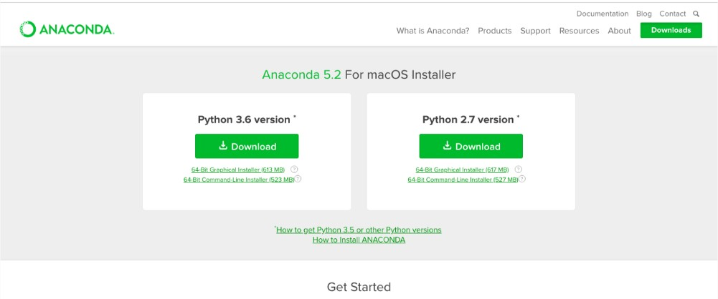

**Fig 2.1 Anaconda Framework**

## Python

Python, which is widely recognised as one of the most powerful programming languages for this particular task, is often used in the process of developing software for artificial intelligence. In the year 1991, Guido van Rossum was the one who initially developed the programming language that is today known as Python. It is a basic high-level oops language that can also be used for general purpose programming. [C] is an acronym for Computer Operating System.

Every single one of the Python programming courses, covering topics such as the "print" and "input" commands, strings, tuples, dictionaries, modules, file operations, data, and time. Python is available in two distinct versions,.Python is a programming language that is simple to learn and may be used for a variety of high-level data structures. There are two distinct versions of Python available. Using the Python programming language, we are able to build virtual environments tailored to the requirements of individual applications. The use of virtual environments is beneficial in avoiding version conflicts with software found in libraries.

## Flask :Web Development Framework

The second most popular framework for developing micro-web applications is called Flask. Flask is used wherever there is a need to construct REST APIs. Other apps are then able to communicate with these application programming interfaces (APIs). The Flask Tutorial covers topics ranging from fundamentals to more advanced aspects of the Python Flask framework. Flask is a programming language that is simple to pick up and can be used by programmers of all experience levels. It was a POCCO team headed by Armin Ronacher that was the first to use the advantages offered by this method. It is the second option that is being considered at this time. In order to construct this application programming interface flask, the WSGI web server gateway interface as well as the jinja2 template were used.

## Numpy

Numpy is the name of one of the most widely used libraries that can be found in Python. It is a large collection of high-level mathematical functions,

One of the most typical applications of this library's capability is the creation of arrays. In addition to that, it is made up of items that are arranged in an array that has several dimensions. As part of its fundamental capabilities, the numpy library can generate random numbers and perform linear algebra, both of which are included in its list of built-in functions. In addition to this, the Fourier transform and a number of other shape modification methods make use of it.

## Tensor Flow

  The artificial intelligence discipline powerful machine learning is focused with the investigation of unstructured and semi - structured data.At its core, deep learning requires the processing of unstructured data in its raw form. Deep learning is an alternative to more traditional methods of machine learning that makes use of knowledge that has already been organized. This is one of the key differences between the sexes.

Users of TensorFlow have access to a vast and diverse set of libraries, tools, and resources provided by the community. It enables developers to build and deploy applications that are powered by cutting-edge machine learning technology, and it offers developers the capacity to do so. One of the most appealing aspects of this framework is the way it makes use of Python to offer a user-friendly front-end application programming interface (API) for the creation of programmes that are ultimately carried out in high-performance, optimised C++. This is one of the most compelling aspects of TensorFlow.

The Google Brain team was initially in charge of building the TensorFlow Python deep-learning framework for their own internal use. This library was initially only available to Google employees. Since that time, the open-source platform has seen significant use in a variety of settings, including production contexts as well as R&D and development systems.

## 2.4 Hardware and Software Requirements

**HARDWARE REQUIREMENTS:**

* System : I3 and above
* Hard Disk : 500GB.
* Monitor : 15 inch VGA Color.
* RAM : 4GB

**SOFTWARE REQUIREMENTS:**

* Operating System : Windows 10 and above.
* Programming Language : Python 3
* Tools :Anaconda,Spyder

# CHAPTER -3 SOFTWARE REQUIREMENT SPECIFICATION

## 3.1 Introduction

Software is required. The interest in software development begins with specification. It starts with an introduction that explains the device's purpose, scope, and outline. This ambition necessitates conversing with individuals and learning about their desires. It's also a well-known description of the gadget's product viewpoint, feature, and some user qualities. It also includes a specification. outlines the overall useful requirements, performance requirements, and design restrictions. The SRS is a means of converting a customer's concept (the input) into a formal report (the output of the requirement section). The software Requirement Specification document is set up in such a way that it aids in validation and device design. The software requirement specification is a document that captures the needs of the end user. and reports to the development team. Requirements, objectives, and non-functional specifications make up a requirement report. The following is a short list of requirements**.**

Necessity is characterized as need might have arisen by a client to take care of an issue or accomplish a goal; a condition or capacity that should be met or had a framework to fulfill an agreement, a norm, a determination, or other officially forced report. In programming necessity of proposed framework, that is to say, the limits that the framework, which is yet to be created, ought to have. The product necessity detail (SRS) depicts what the proposed programming ought to manage without portraying how the product will make it happen. It has a report which totally depicts outer way of behaving of the product. It is the main occupation of the product designer to concentrate on the framework that should be created and indicates the client prerequisite prior to going for the planning part.

### 3.2 Functional Requirements

* collect the required dataset.
* cleaning the collected data according to their needs.
* find the best-suited machine learning model for the pre-processed data.
* train the chosen MLmodel by using the train and the test dataset.
* Evaluate the trained model's accuracy.

### 3.3 Non-functional Requirements

This criterion is a benchmark for analyzing and, in some ways, defining a system's behavior. The look of the system is defined by non-functional requirements, whereas the functionality of the system is defined by functional requirements. It is a non-functional requirement to have a software development environment.

**Reliability-** is the The system has the capability to perform and sustain its responsibilities in both anticipated and unanticipated circumstances.

**Security**- concerning security or privacy issues related to the creation or protection of information used in the creation. Describe any operator identity verification requirements.

.

**Usability**-The term usability- It also mentions a method for purifying ease of use during the design process.

.

**Interoperability**-that property stating to the ability of diverse systems and administrators to work together (inter-operate).

# CHAPTER-4 SYSTEM DESIGN

## 4.1 Introduction

In order to get from a particular issue to a solution, the first step in the process is to design. Manager To begin the process of moving from the issue domain to the solution management, the problem must be defined. As a link between the development of requirements and the finished response, layout plays an important role here. The design method's goal is to provide a model or description of a system that may be used in the construction approach for that system. Known as a "gadget layout," this is the most recent variant. Systemic problem solving is one way to put this approach to work. The layout of a gadget is the most creative and challenging part of the whole process of making a device.

In spite of its complexity, this method makes coding for the recommended machine easier. For the suggested machine, this is a method of providing it Also included are instructions for putting the device into use. There are a few parts to the system that must be taken into consideration. As a result of the research conducted in this section, new forms for presenting the findings will be devised. In the making of the machine. In this particular case, the emphasis is on translating the performance specifications into a layout description.

## 4.2 Architectural Design

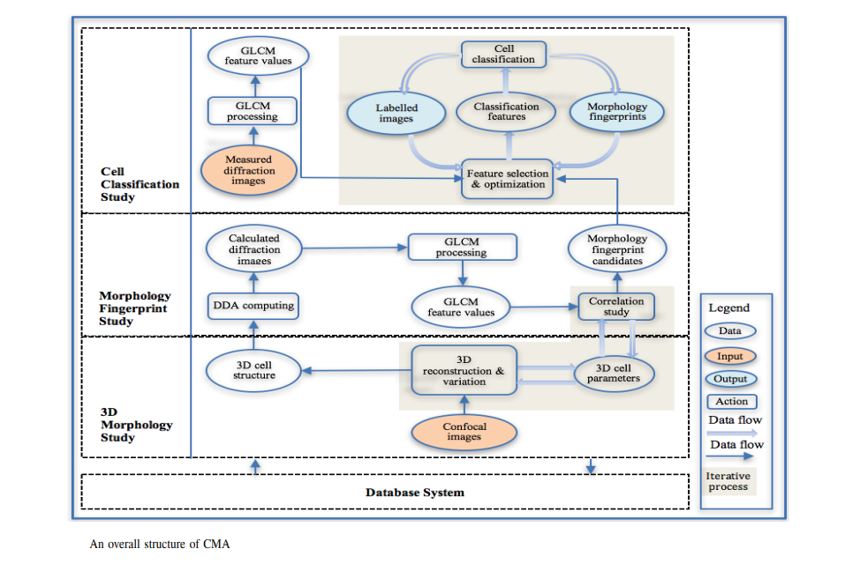

In Figure, we can see the CMA's architecture and working process. All four CMA elements are included in the project. These include the databases, software components for examining cell 3-dimensions and fingerprints on diffractograms, and software systems for classifying cells.. Appropriate features from diffraction pictures are used to obtain morphological fingerprints. The directory is the foundation of CMA, the core of CMA is a set of data analytics algorithms and image processing techniques, and the business of CMA is the pieces of software used to find the morphology fingerprints for quick and accurate classification of cell types based on their diffraction images. An image's textual pattern may be exploited to categorise it using machine learning methods. For each kind of cell, the 3D morphological information is captured in an image created by the laser diffraction technique. As a result, textual patterns derived from diffraction pictures may be used to describe specific kinds of cells in samples.

**WATERFALL MODEL:**

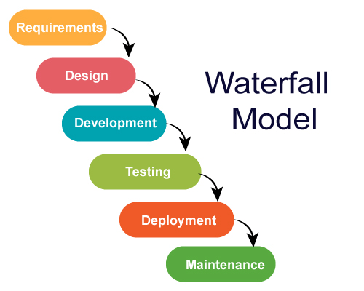

Figure:4.3: These six steps is important for waterfall model When developing the software.

Requirements: All of the requirements have been thoroughly recorded, discussed, and agreed upon.

Design: Your teams will design the system by making use of the previously specified requirements.

During this stage of development, coding will take place.

Testing: Testing of the product may start after all of the coding has been completed.

During the phase known as "Deployment," the product is at this point considered to be finished, and your team will now submit the deliverables so that they may be deployed or launched.

Maintenance: This item has been sent to the customer and is now being used.

# CHAPTER-5

# DETAILED DESIGN

## 5.1 Use Case Diagram

The use-case analysis in the Unified Modeling Language is what's discussed and constructed in the use-case diagram, which is a behavioural diagram (UML). Its objective is to provide a graphical illustration of the operation of the machine in terms involved, the objectives they want to achieve (which are shown as use instances), and any dependencies that those use instances may have. The visual representation of the use case's principal function is to show its purpose. The participants in the system's parameters will be shown in this illustration. The interaction between actors is not included in the image that represents the use case. If this interaction is necessary for a comprehensive description of the behaviour that is expected, the bounds of the device or use case may need to be rethought. One of the assumptions that will be applied in the employment instance is going to be about the interaction between actors, for instance.

After that, we can ask the actors to engage in some kind of conversation with the gadget. Actors are any characters or components of a tool that are responsible for activating its functionality. It is typically a machine or a person, and as such, it requires an entity that is pertinent to the operations of the device with which it is interacting. This thing might be relevant in a number of different ways. After the actor and the use case have both been recognised, a connection may then be made between the two entities. After that, we may consider recruiting actors to interact with the contraption we have created. Theactorsarethecharactersorelementsthatactivateatool'sfunctionality. It is seldom a computer or a person; as a result, it requires an entity that is pertinent to the operations of the device with which it is interacting. This entity might be a machine, a person, or both. After the actors and the use cases have both been recognised, a connection may then be made between the two entities through the establishment of a relationship. It keeps track of the number of times an actor interacts with the system. At any one moment, an actor may have several interactions with a single use case or device.

User

Import Dataset

Train Data using ML

Massive Scale Image

Verification and Validation

Training Base Predictors

Prediction

**Fig 5.1 Use Case Diagram**

## 5.2 Sequence Diagram

As an interaction diagram in the Unified Modeling Language (UML), a sequence diagram depicts how and in what order certain approaches work together. Message Collection Charts are shown here. Unique procedures or things are shown as parallel vertical lines (lifelines) and horizontal arrows are used to communicate between them. in the order in which they came up with them, the texts they have shared Simple runtime situations may now be graphically described.

Preprocessing

Import Dataset

Stemming

Words

Train Data

using ML

Data Cleaning

Massive Scale

Image

Directed Acyclic

Graph (Dag):

Verification

and Validation

Training Base

Predictors

Training Base

Predictors

Data gathering methods

Representation and quality of data is first

Reducing inflected

The morphological root of the image

Remove the noisy data

Correct the inconsistencies in data

Different subsets of courses

A single area is often limited

Prediction of Massive Data

**Fig: 5.2. Sequence Diagram**

5.3 **Collaborative Diagram:**

Collaboration figure illustrates relationships and interactions between UML software items. This is a communication or connection diagram (UML). The approach has been around for more than a decade, but new analytical paradigms have enhanced it.

Communication diagrams employ the same free-form layout as object diagrams. Messages are numbered and placed next to the link they travel across to keep their order in a free-form design. Reading a connection diagram starts with message 1.0 and continue from there.

Training Base

Predictors

Import

Dataset

Train Data

using ML

Massive Scale

Image

Verification

and Validation

1: Data gathering methods

2: Representation and quality of data is first

3: Reducing inflected

4: The morphological root of the word

5: Remove the noisy data

6: Correct the inconsistencies in data

7: Different subsets of courses

8: A single area is often limited

9: Logistic regression

**Fig:5.3- Collaborative Diagram:**

# CHAPTER-6 IMPLEMENTATION

**6.1 Modular description and methodology**

Diffraction Image

We show how our method may be used to the categorization of diffraction pictures of biological cells. An reliable classification of cell kinds is possible using the 3D morphological characteristics of a cell obtained in a diffraction picture. We are all made up of cells.

These organisms have a wide range of 3D shapes of internal organelles to support their phenotypic and functional diversity. Many disciplines of biology and life science study rely heavily on cell assays and classifications.. In contrast to genetic and molecular assay approaches, morphological assay is more suited for single-cell studies.

Machine Learning

A polarizing fracture image circulation cytometer (p-DIFC), designed and produced by co-author Hu to characterize and characterise 3D geometry, is used to obtain diffraction pictures of single cells.

Many diffraction pictures may be utilize the information using CMA tools, which provide texture parameters in near-real time. Optimization and identification of parameters (i.e., morphological fingerprints) for completing cell assays directly on diffraction pictures are performed employing machine learning approaches like Classification Algorithm (SVM) [8] and texture features. [9, 10]

Deep Learning

Two new machine learning approaches are explained in this section as potential solutions to problems. SVM (Support Vector Machine) is a method for automatically identifying aberrant photographs and distinguishing it among normal ones, whereas machine learning algorithms is used for this. Even though we tested a variety of SVM kernel functions, the results were obtained that used the linear backpropagation algorithm alone.

Metamorphic Testing

It is tough to predict whether a cell's appearance has been accurately rebuilt using just a 3D reconstruction software application. A last problem concerning ADDA is that everything is impossible to ascertain whether or not the output is right given any given input. Non-testable systems like these two main research software applications are common since there are no test oracles available. Consequently, we used metamorphic testing to verify and verify these products, as well as an evolutionary strategy to producing MRs.

Algorithm:

As mentioned in Section IV, diffraction pictures of cells may be utilised to reliably categorise the normal cells, aggregated tiny particles, and fragmented cells. This means that we may use ADDA to generate diffraction pictures for each scatterer and see whether the machine learning algorithms can properly classify each one.

CMA is a collection of scientific software tools, machine learning techniques, and a large-scale cell picture library. We've also built a methodology for rigorously validating huge picture data and verifying software systems and machine learning techniques.

The selection and validation of enormous amounts of picture data in CMA were automated using a variety of machine learning algorithms combined with image processing methods.

Technique:

Machine learning features such as data augmentation, extraction, and selection are also treated in this article. Fig. 1 depicts the planned verification and validation structure in this article.

For example, first foundations barrier seems to be a strategy providing autonomous selection and validation of large data, the middle layer is a way to verify and validate machine learning techniques, and the top layer is an approach for testing domain modelling systems, data analytics tools and applications.

Automating the selection and validation of huge scale account of the views in CMA was accomplished using a number of machine learning techniques along with image processing techniques. A feature selection method was included in the framework to help to choose best machine learning features for the conduction of a particular research.

Methodology:

Big data's four characters, on the other hand, create additional challenges for the jobs of validation and verification. So according data selection and validation, for example, a significant volume and variety of big data constitute a huge difficulty for the selection of big data and validation of big data. Existing research has demonstrated whether datasets comprising aberrant data may greatly reduce the accuracy of data analysis.

Data validation and automation, verification and testing on analytics software, are the main areas of study in this work. Machine learning features such as feature representation, extraction, and evaluation are also addressed throughout this article.

Big data and tools for doing research and developing big data applications may also be found in this resource. Information management, analysis, research, applications, and sharing are included into the creation and morphology-based cell assay tools by CMA using big data methods.

**Decision Tree**

A kind of Supervised Machine Learning, Choice Trees separate samples along a specified boundary. To understand the tree, humans need to look at its chosen hubs and leaves in more detail. We make our decisions based on what's on display. In addition, the information is divided at the choice hubs.

Directed learning computations have a position in the group of choice tree branches. Relapse and grouping concerns may be dealt with using a decision tree calculation, which is distinct from conventional administered learning methods.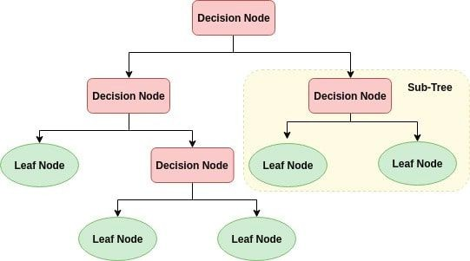

Step1:

Place the dataset's most important criterion at the root of the tree. Entropy in Crop Dataset has been calculated as a result

According to H(S), which is also termed as Shannon entropy for a constrained set S, entropy reflects how much uncertainty or chance there is in crop information in terms of H(S).

Step2:

Subdivide the toolkit into manageable components. It is important that each subset has material that has a comparable motivation for an attribute. Break down the data into smaller groupings by focusing on that attribute as a decision hub.

Area, temperature, pH, and other navigational components are included in the created dataset.

The next step is to choose a home with the maximum possible ceiling height. Gaining Knowledge

Step3:

Accumulate information from existing assessments and use it to predict harvest information in light of the sort of money generated on the spot. Stage 1 and stage 2 should really be repeated on each subset until blade hubs are found in all of the tree's components.

Decision Tree Pseudocode

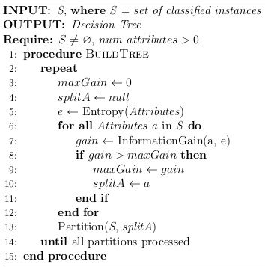

## 6.2 Screenshots

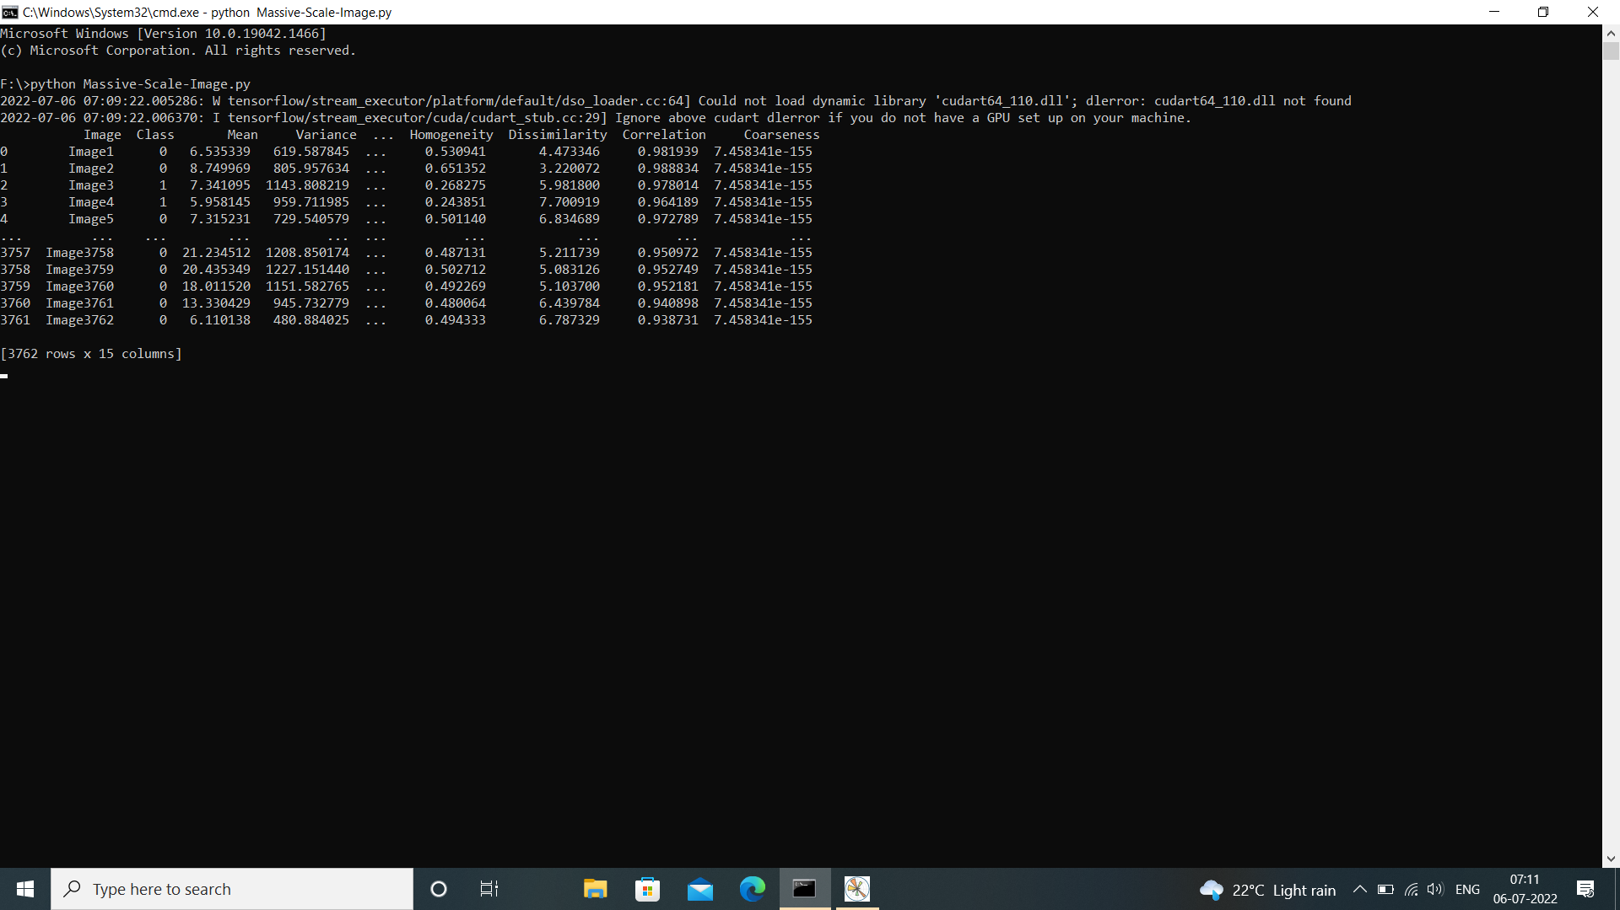

Screenshot1-Compiling of python program screen

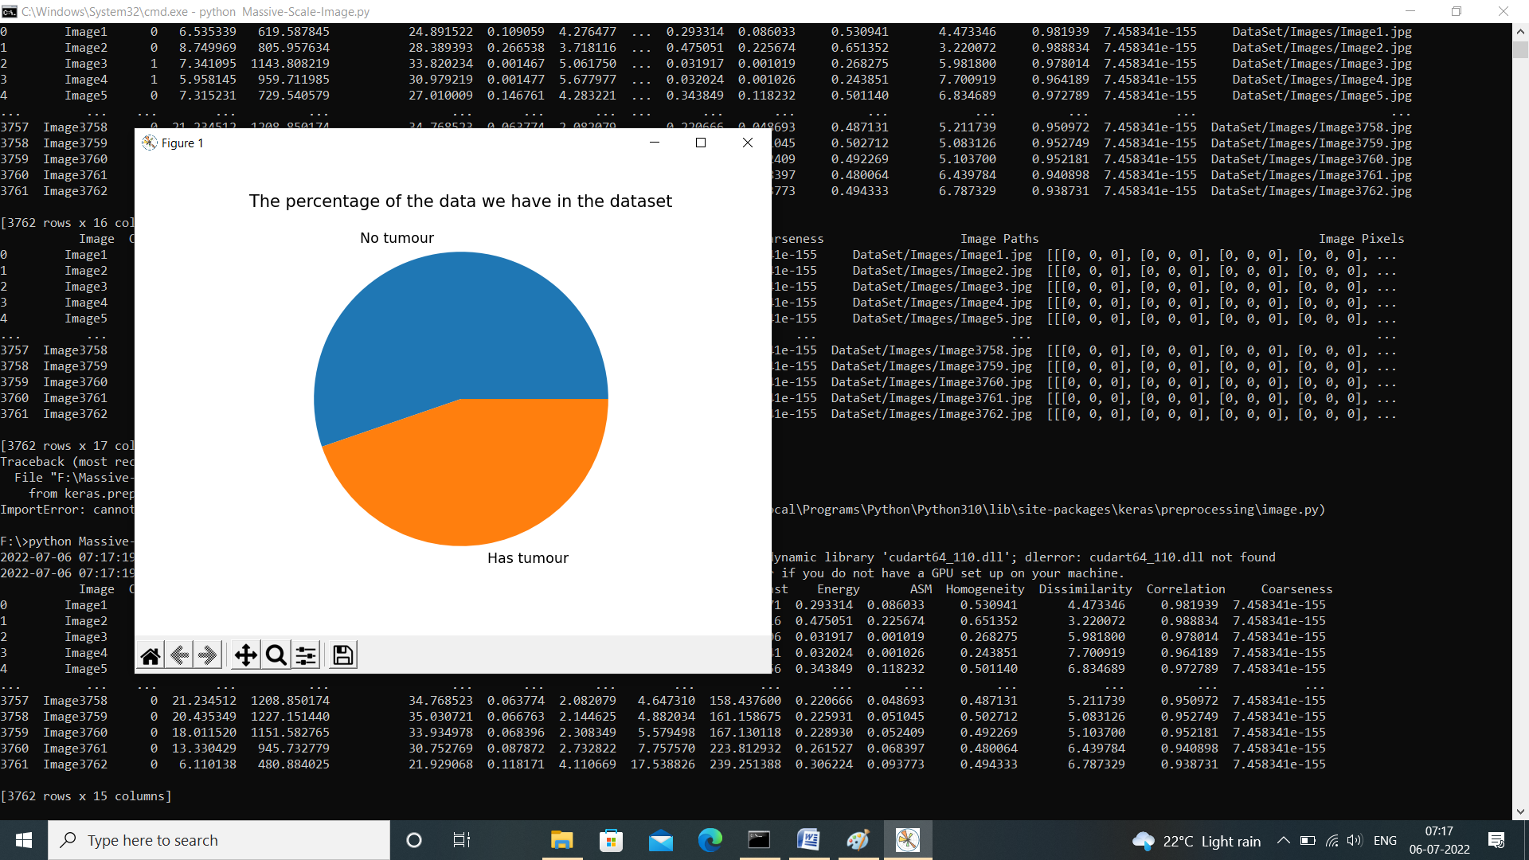

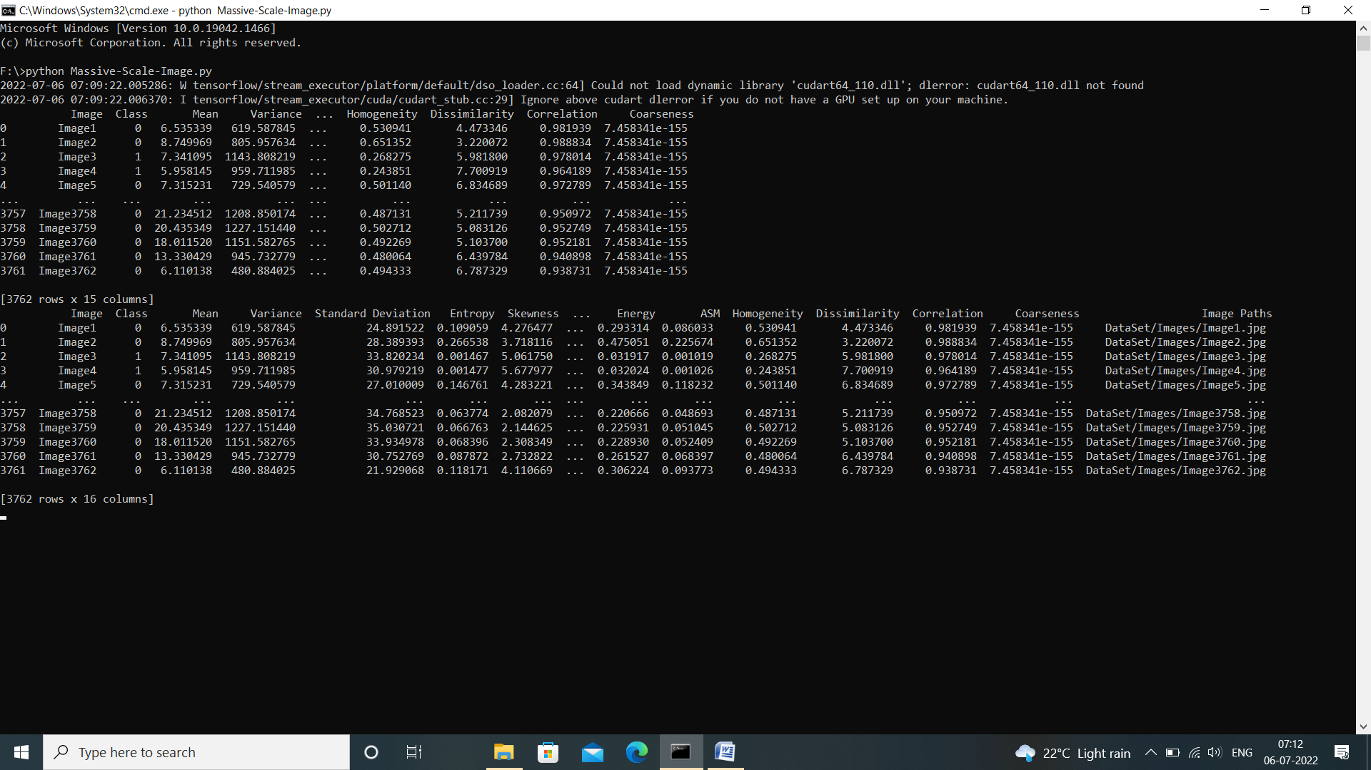

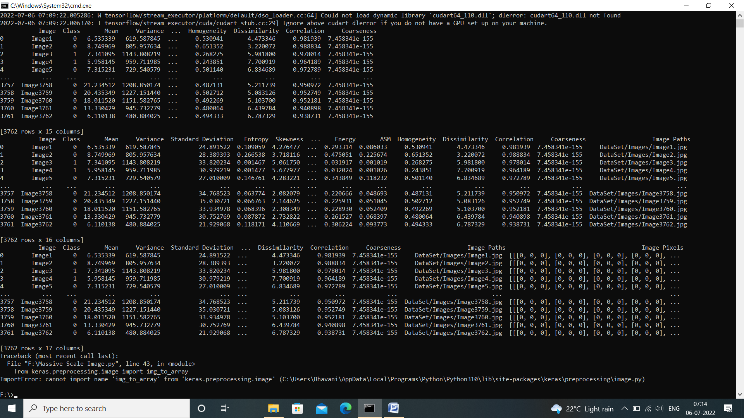

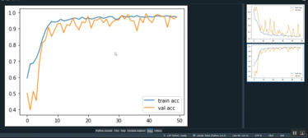

# CHAPTER 7 SYSTEM TESTING

**7.1 Introduction**

Trying out is the process of determining the equipment's strengths and weaknesses. It's completed by contrasting the appliance's functionality with the case of ease response, suitability of expertise codes, stage of use, and common reliability. Moreover, testing is the process of running a programmed with the specific goal of identifying and correcting errors, as well as verifications of the program's functionality. Software trying out, searching at the testing method hired, could be carried out at any time within the development manner, but the most important take a look at attempt is used after the requirements are defined and coding method has been finished.

**7.2 Types of testing**

1. Unit Testing
2. Integration Testing
3. System Testing
4. Black Box Testing
5. White Box Testing

## 1.Unit Testing

In this testing checking out utility developer exams the gadget. the entire utility is fashioned of distinct modules. Unit testing focuses on each sub-module unbiased of 1 any other, to find mistakes. This allows the programmer to hit upon mistakes. even as testing the module the idea of trace and breakpoints are implemented at extraordinary degrees of trying out. The unit testing of this task turned into wiped out each and each module with certain test facts to ensure that the program works correctly. The unit testing becomes administered correctly.

## 2. Integration Testing

Integration testing is intended to test the device as a whole. Its goal is to thoroughly test the device while all of its modules and sub modules are fully integrated.. This testing is done to ensure that all of the modules that function together correctly while they're separate work together without any anomalies when they're combined. When you check out a gadget, you can rest assured that all of the connected modules will function together to get the job done. The venture became tested with all its modules incorporated and ensured that there were no mistakes. Samples of records had been keyed into the equipment. it is been visible the equipment is functioning flawlessly, to the first-rate of the consumer.

## 3.System Testing

System testing can be defined in a variety of ways, but the most basic definition is that validation is successful when the system performs in a way that can be fairly predicted by the user. Validation testing ensures that the system satisfies all of the system's practical, behavioral, and overall performance requirements. The task was tested with all its modules and ensured that there have been no errors. it has been visible that the gadget is running perfectly, to the satisfaction of the consumer meets all of the requirements of the person.

## 4.Black Box Testing

Black box trying out is a technique to checking out wherein the tests are derived from this system or element specification. The system is a “black container “whose behavior can handiest be decided with the aid of reading its inputs and the associated outputs. Black field is the handiest worried with the functionality and now not the implementation of the software program.

## 5.White Box Testing

White container testing makes use of the machine's internal perspective to set up test cases based on its internal structure. To pick out all paths through the software, you'll need programming skills. The tester examines case inputs in order to exercise paths through the Code and find the proper outputs. for the reason that exams are based on the actual implementation, if the implementation

* 1. **7.3 Test Cases**

|  |  |  |  |  |  |
| --- | --- | --- | --- | --- | --- |
| **TC**  **No** | **Positive scenario** | **Required**  **Input** | **Expected output** | **Actual output** | **Test**  **Result** |
| 1 | Upload datasets | Upload video | Should successfully upload | uploaded | Pass |
| 2 | Pre-processing | Process dataset | Remove unwanted datasets | Unwanted datasets are removed | Pass |
| 3 | train image | Image processing | Identify object | Object detected | Pass |
| 4 | Classification | Objects are  classify | Identify the object and classify which type of object it is | Object classified | Pass |
| 5 | Performance analysis | Find Accuracy | Display Accuracy information | Accuracy information displayed | Pass |

|  |  |  |  |  |  |
| --- | --- | --- | --- | --- | --- |
| Test-Case | Test-Purpose | Test condition | Expected-  outcome | Actual-result | Pass-or-  Fail |
| Install python | Installing python3.7 | Installation Done | Installation Done | Installation Done | Pass |
| Install python | Installing python3.7 | Installation Done | Installation Done | Installation Done | Fail |
| Load Data | Load datasets In CSV  format. | If the data is not in the CSV format, shows a  Error message. | Load datasets. | The data is loaded Successfully in  CSV format. | Pass |
| Pre Process data | CSV data | If values are missing, or improper data | Preprocessing isdone | As Expected. | Pass |
| Tokenization | CSV data | Datasets Tokenization | Tokenization  n  Is Done | As Expected. | Pass |

Failed test Cases

|  |  |  |  |  |  |
| --- | --- | --- | --- | --- | --- |
| Test Case | Test Purpose | Test  condition | Expected  outcome | Actual result | Pass or  Fail |
| Preprocess data | CSV data | If values are missing, or improper data | Preprocessing isdone | Preprocessing is notdne. | fail |
| Tokenization | CSV data | Datasets Tokenization | Tokenization  Is Done | Failed to do Tokenization | fail |

# CHAPTER-8 CONCLUSION

Using CMA as a template, we've developed a way to guarantee that large amounts of data systems are up to the task It was recommended to use SVM and deep attempting to learn methods to automate the selection process for data, as well as an observational study technique for process systems in order to enhance machine learning-based classification accuracy.

Machine learning was employed to design and refine MRs while iterative metamorphic programming was used to validate scientific software in CMA. A confusion matrix and cross validation were used to assess the data mining algorithms.

Using this methodology, you can verify and validate any large data system in a systematic and rigorous manner. Big data performance assessment and authentication utilising machine learning techniques will be a significant emphasis in the future.

# CHAPTER-9 FUTURE ENHANCEMENT

Testing and research image segmentation would also provide a somewhat more accurate diffraction image categorization feature set. The influence of image classification on classification accuracy and machine learning expenditures has also been highlighted.

The methodology suggested in this study might allow more sophisticated feature selection algorithms, such as the one described in this paper. Deep learning of biological pictures may not be achievable using the feature selection outlined above.

A possible approach in our study of reinforcement learning of diffraction pictures is resizing the images indiscriminately or pooling them.

And use this approach, you can validate the proposed any large data system in a systematic and rigorous manner. Big data quality evaluation and validation employing machine learning approaches will be a key emphasis throughout the future.

# Appendix-A BIBLIOGRAPHY

**Research Paper References**

[1] V. Gudivada, R. Raeza-Yates, and V. Raghavan, “Big data: Promises and problems,” IEEE Computer, vol. 48, no. 3, pp. 20–23, 2015.

[2] Y. Bengio, “Learning deep architectures for ai,” Foundations and Trends in Machine Learning, vol. 2, no. 1, pp. 1–127, 2009.

[3] Apache. (2016) Hadoop. [Online]. Available: <http://hadoop.apache.org/>

[4] V. Gudivada, D. Rao, and V. Raghavan, “Renaissance in database management: Navigating the landscape of candidate systems,” IEEE Computer, vol. 49, no. 4, pp. 31–42, 2016.

[5] J. Zhang, Y. Feng, M. S. Moran, J. Lu, L. Yang et al., “Analysis of cellular objects through diffraction images acquired by flow cytometry,” Opt. Express, vol. 21, no. 21, pp. 24 819–24 828, 2013.

[6] R. M and T. Poggio, “Models of object recognition,” Nature Neuroscience, vol. 3, pp. 1199–1204, 2000.

[7] K. Jacobs, J. Lu, and X. Hu, “Development of a diffraction imaging flow cytometer,” Opt. Lett., vol. 34, no. 19, p. 29852987, 2009.

[8] (2016) Adda project. [Online]. Available: https://github.com/adda-team/ adda

[9] T. Y. Chen, S. C. Cheung, and S. Yiu, “Metamorphic testing: a new approach for generating next test cases,” Tech. Rep. HKUST-CS98- 01, Dept. of Computer Science at Hong Kong Univ. of Science and Technology, 1998.

[10] J. Ding, D. Zhang, and X. Hu, “An application of metamorphic testing for testing scientific software,” in 1st Intl. workshop on metamorphic testing with ICSE, Austin, TX, May 2016.

**Books:**

* [Machine Learning with Python for Everyone By Addison Wesley](https://www.amazon.com/dp/3816772374?tag=uuid10-20" \t "_blank)
* [Software Development from A to Z by](https://www.amazon.com/dp/1983172383?tag=uuid10-20" \t "_blank) [[Karoly Nyisztor](https://www.amazon.com/dp/1983172383?tag=uuid10-20" \t "_blank)](https://bookauthority.org/author/Karoly-Nyisztor)[,](https://www.amazon.com/dp/1983172383?tag=uuid10-20" \t "_blank)[[Monika Nyisztor](https://www.amazon.com/dp/1983172383?tag=uuid10-20" \t "_blank)](https://bookauthority.org/author/Monika-Nyisztor)

**Websites:**

* [www.w3Schools.com](http://www.w3Schools.com)
* https://www.geeksforgeeks.or